**MONTHLY SUMMARY TO THE CABINET IN RESPECT OF**

**CENTRAL GROUND WATER BOARD - November, 2019**

1. **IMPORTANT POLICY DECISIONS TAKEN AND MAJOR ACHIEVEMENTS OF THE MONTH:**
   * 1. **Significant Findings from National Aquifer Mapping and Management Programme:**

**High Discharge Exploratory and Observation Wells-** During the month of November 2019, Ten (10nos) high discharge exploratory and 3 (3nos) observation well have been drilled by CGWB in the States of Maharashtra, West Bengal, Jharkhand, Chhattisgarh, Tamil Nadu, Andhra Pradesh, Telangana and Karnataka. The details of the wells are given as below-

* 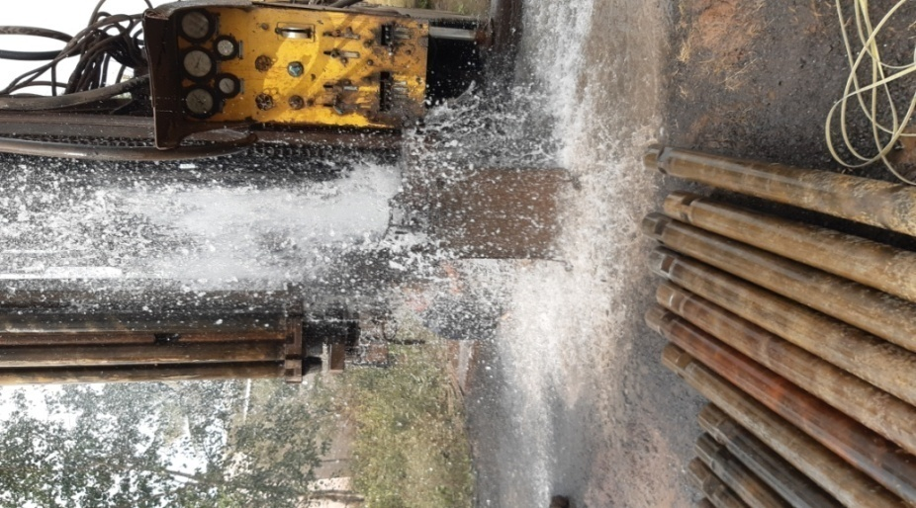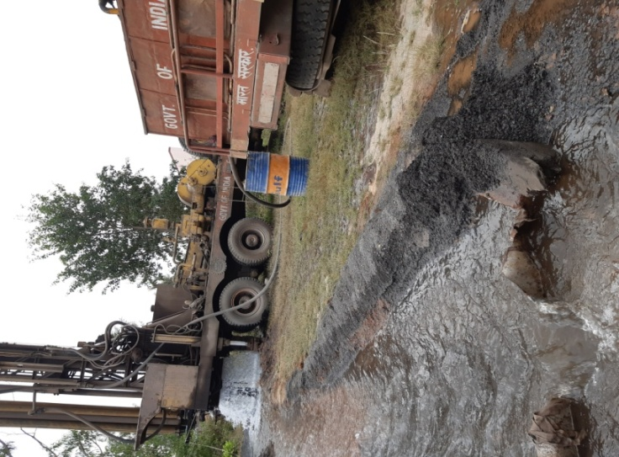An exploratory well drilled to a depth of 160.10 metre below ground level (m bgl) at Samarth gaon village in Satara taluka of Satara district, Maharashtra has yielded a discharge of 730.8 litres per minute (lpm) in Deccan basalts. The quality of ground water was fresh with EC of 650μS/cm at 25°C.
* An exploratory well drilled to a depth of 200.00 m bgl at Kodamendhi village in Maudha taluka of Nagpur district, Maharashtra has yielded a discharge of 465.6 lpm in metamorphic terrain. The quality of ground water was fresh with EC of 847 μS/cm at 25°C.

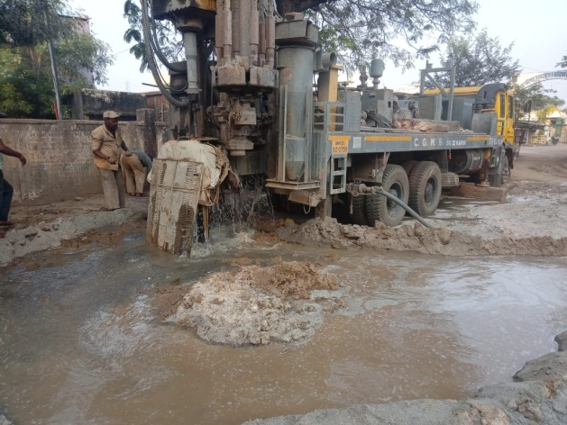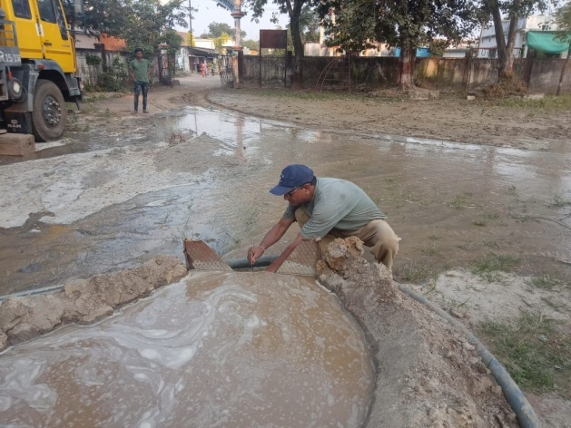

* Exploratory well drilled upto a depth of 147 m bgl at Rantua site, Gopiballavpur-II block, Paschim Medinipur district, West Bengal reported discharge of 1140 lpm by air Compressor, which is a considerable good yield. Granular zone have been tapped at a depth ranging from 99 – 111 mbgl.
* One Exploratory well drilled in hard rock to a depth of 123 m bgl at Kasturba Gandhi Balika Unch Vidyalay Gopalganj, Nirsa block, Dhanbad district, Jharkhand. Fracture encountered at 65 m bgl. Compressor discharge from the well has been measured as 738 lpm.
* One Observation well drilled in hard rock to a depth of 74.20 m bgl at Kasturba Gandhi Balika Unch Vidyalay Gopalganj, Nirsa block, Dhanbad district, Jharkhand. Fracture encountered at 43 & 65 m bgl. Compressor discharge from the well has been measured as 738 lpm.
* 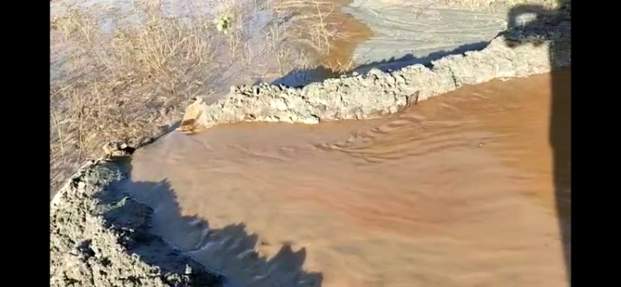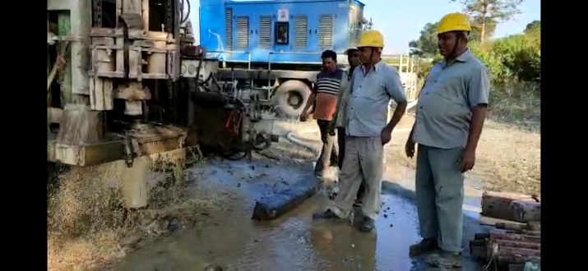An exploratory well was drilled at Kakna village, Rajpur Block, district Balrampur, Chhattisgarh with 720 lpm discharge of ground water.

90o V notch discharge

Drill time discharge 720 lpm

* An EW drilled to a depth of 213 m bgl at T. Pudur, Kallugudi Block, Madurai District, Tamil Nadu yielded a discharge of 200 lpm in highly fractured Granitic Gneiss.
* One EW drilled to a depth of 200 m bgl at Mampatti (Eriyur), Singampunari block, Sivagangai District, Tamil Nadu yielded a discharge of 261 lpm in highly fractured Granitic Gneiss.
* 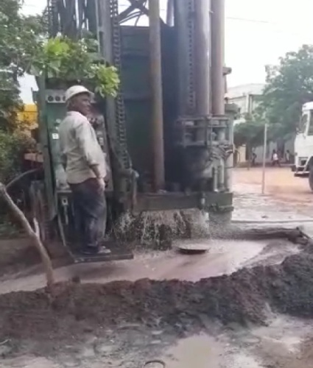Potential aquifer zones with high discharge of 256 lpm were encountered between 42 to 43 m bgl and 127 to 128 m bgl while drilling EW in hard rock formation at Mallepali village, Brahmamgari Matham Mandal, YSR Kadapa District, Andhra Pradesh State.
* Potential aquifer zones with high discharge of 1967 lpm (EW) are encountered between 19 to 20 m bgl while drilling EW in hard rock formation at Sudimella village, Yellandu Mandal, Khammam District, Telangana State.
* One EW was drilled at Bindiganavile village, Nagamanagala taluk, Mandya district, Karnataka to a depth of 200.60 m bgl with a discharge of 260 lpm.
* An observation well at Bindiganavile , Nagamanagala Taluk , Mandya, Karnataka state drilled down to a depth of 200.60 m yielded a discharge of 504 lps. The aquifer is Granitic Gneiss and the productive zones were encountered at 148-148.5, 171-171.5, 183-183.5, 186-186.5mbgl.
* An observation well at Mugalkod , Raibag Taluk Belagaum drilled down to a depth of 200.00 m has yielded a discharge of 315 lpm in a Basaltic aquifer.

**(b) Training Programmes conducted by National Ground Water Training & Research Institute (NGWTRI).**

Number of training programmes have been conducted by RGNGWTRI, Raipur and various Offices of CGWB (under the aegis of RGNGWTRI) during November, 2019 for imparting training to CGWB Officers and Officials, ground water professionals from other Central and State Government Agencies, Public Sector Undertakings and NGOs, Faculty Members and Students from the Academics and semi-professionals and grass-root level stakeholders. Three types of training courses conducted as Tier-I, Tier-II and Tier-III are as follows.

* **Tier-I:** Tier-I training courses are conducted at RGNGWTRI, Raipur. During the month of November2019, 6 Nos. of Tier-I training courses were conducted wherein 144 persons got training. A total of 38 nos. of Tier–I training courses have been conducted till November, with 733 participants in all (175 women participants).
* **Tier-II:** Tier-II trainings are imparted in Regional Offices for State Govt. Officers. During the month November, 2019 Tier-II training course could not be conducted. Against the annual target of 20 trainings, so far 8 nos. of training courses have been completed in which 300 trainees have participated including 66 women participants.
* 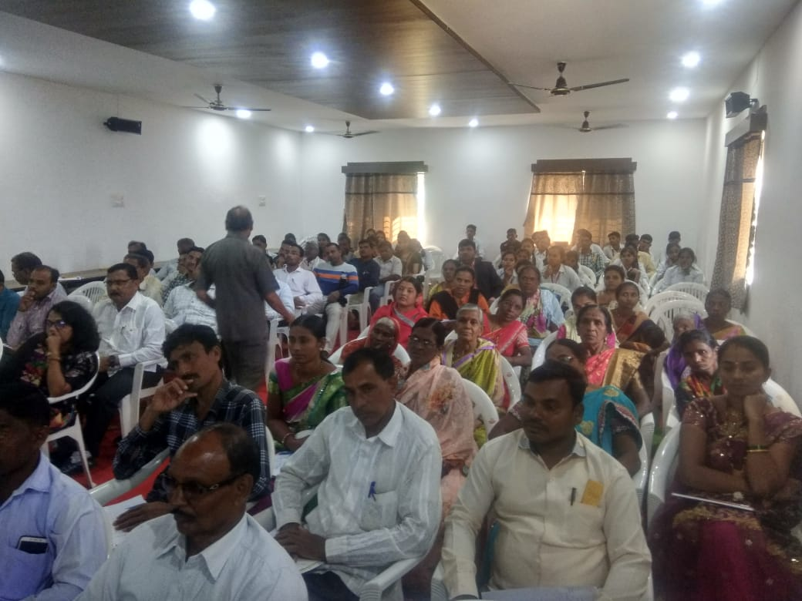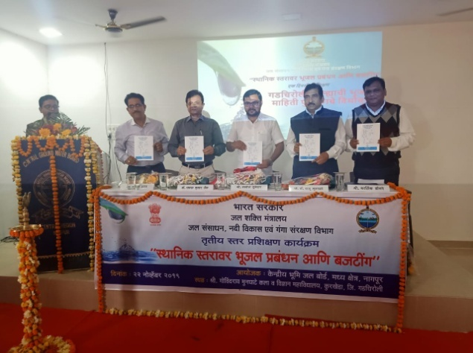**Tier-III:** Tier-III trainings are imparted to the grass root level stake holders on basic skills of ground water for assistance in data collection and field studies. During the month November 2019, 5 Nos of Tier-III training courses were conducted imparting training to 664 participants including 269 women. Against the annual target of 50 trainings, so far 19 nos. of training courses have been completed in which 2559 trainees have participated including 777 women participants.

Tier-III training program organised at Shri Govindrao Munghate Arts and Science College, Kurkheda taluka, Gadchiroli district, Maharashtra

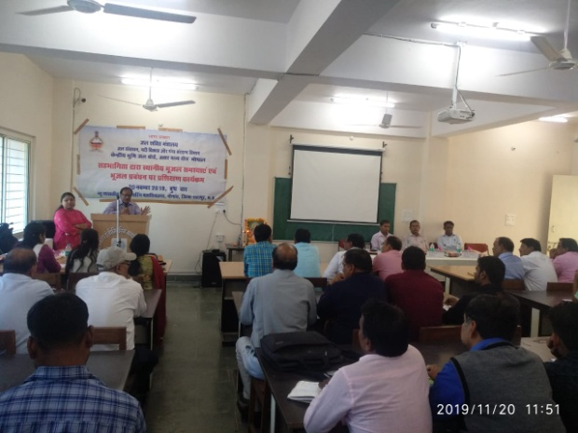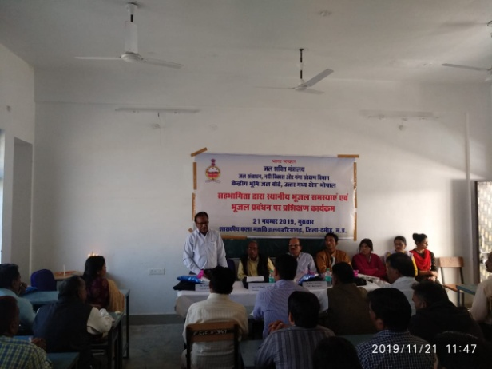

Tier III training program at Nowgaon, district Chattarpur on 20.11.2019

Tier III training program at Batiyagarh, district Damoh on 21.11.2019

**(c) Visit of Hon’ble Minister/ Secretary/ Chairman/ Members:**

* Sh. Gajendra Singh Sekhawat, Hon’ble Union Minister, MoJS visited Kolkata on 05.11.2019 regarding Ganga Aamantran Expedition at Farraka. Sh A. Kar, HOO and officers from CGWB, Kolkata, West Bengal met with Hon’ble Union Minister, MoJS at Kolkata on the same day to apprise him about the progress and activities of the Region.
* Sh. Rattan Lal Kataria, Hon’ble Minister of State, MoJS, visited Kolkata on 08.11.2019 regarding Ganga Aamantran Expedition at Farraka. He was briefed about the progress and activities of the Region by Shri Amlanjyoti Kar, HOO and Sh. S. K. Adhikari, Sr. Geophysicist, CGWB Kolkata.
* Sh. K.C. Naik, Chairman, CGWB visited RGI. Raipur on 25.11.2019 and Inaugurated the Induction Level Training Course 2019-20. He visited RGI, New building on 26.11.2019 which is under progress and reviewed the progress of work done. He also visited CGWB, Raipur, Chhatisgarh office on 26th November and inspected the office regarding the progress of the region as per AAP 2019-20.
* Sh. G.C. Pati, Member- HQ CGWB visited RGI. Raipur on 14th& 15th November 2019 and inspected RGI, New building which is under progress and reviewed the progress of work done. He also visited CGWB, Raipur, Chhatisgarh on 15th November and discussed with all the officers and officials regarding the progress and other day to day activities.
* Dr. Indranil Roy, Sc. C and Sh. S. Upadhyay, Asst. Hg. received Secretary, Department of Water Resources, RD & GR at Patna Air Port on 18.11.2019 during visit to Patna on the way to Sonepur, Bihar. Dr. Indranil Roy, briefed secretary about works being carried out in MER Patna.
* 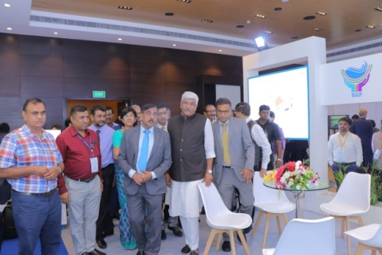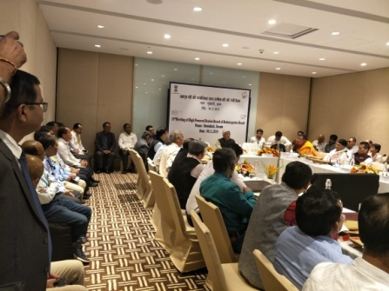Hon’ble Minister visited Shillong on 07.11.2019 to attend 2nd meeting of Governing Body of NERIWALM Society at State Convention Centre, Shillong. Minister also taken review of progress of North Eastern States on 09.11.2019 at Guwahati. Secretary & Joint Secretary, MoJS attended the meeting. Dr P Nandakumaran, Member (East) CGWB presented the activities of CGWB in the North Eastern Region & progress of work during the meeting. Member (East) reviewed the progress of work and held technical discussion with the officers at Regional office, Guwahati.

Secretary & Joint Secretary, MoJS attending Hon'ble Minister (Jal Shakti)

Hon'ble Minister (Jal Shakti) while reviewing progress of North Eastern States on 09.11.2019

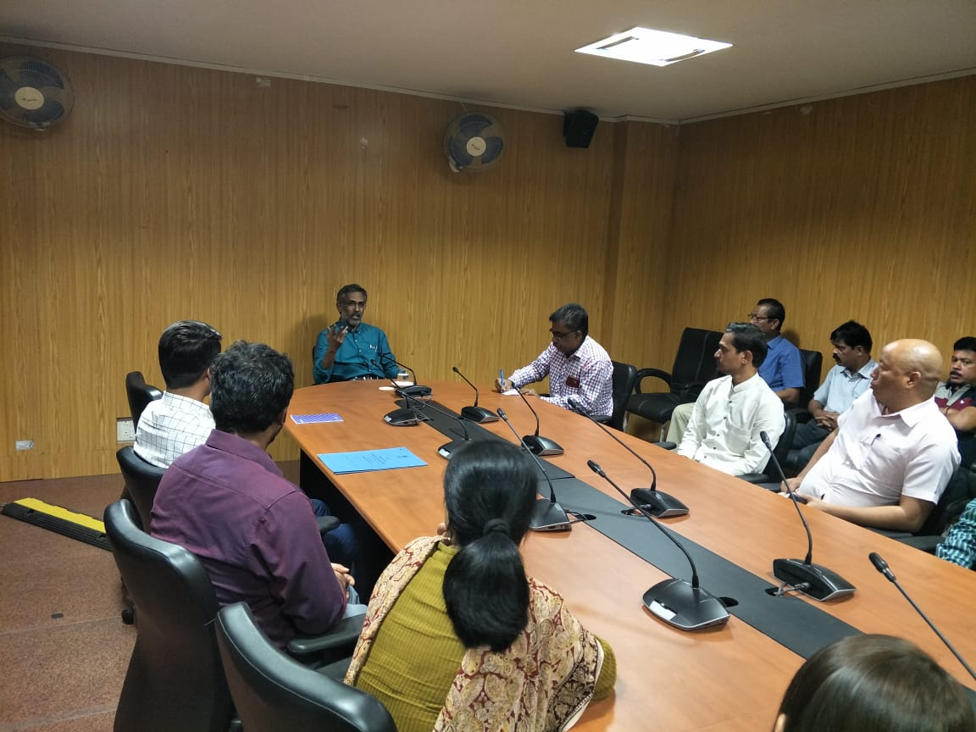

Dr P Nandakumaran, Member (East) reviewing progress of CGWB, NER on 09.11.2019

* 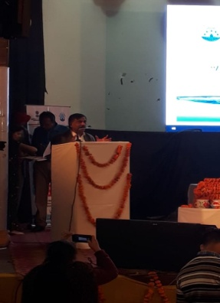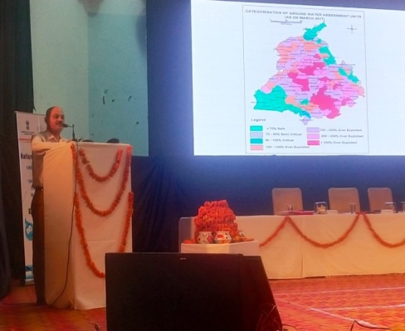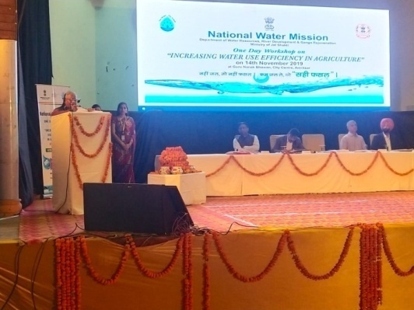Hon’ble State Minister Shri Ratan Lal Kataria, Ministry of Jal Shakti and Sh. U. P Singh, Secretary, DoWR, RD & GR, MoJS attended a one day workshop on “Increasing water use efficiency in Agriculture” at Guru Nanak Bhawan, City Centre, Amritsar on 14.11.2019 organised by National Water Mission. Scientist of CGWB gave presentation on GW scenario.
* Hon’ble Union Minister for Jal Shakti, **Sh. Gajendra Shekawat**, chaired the review meeting for Southern States held at Hyderabad on 11.11.2019. Sh. Akhil Kumar, Joint Secretary (GW), Department of Water Resources, RD & GR attended the meeting along with Sh. Sunil Kumar, Member (South), CGWB and Regional Director of the respective region of the Board.

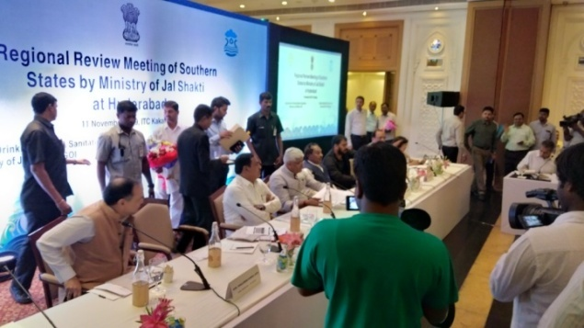Hon’ble Union Minister Jal Shakti, Sh. Gajendra Shekawat, chaired the Review Meeting for Southern States held at Hyderabad on 11.11.2019

**(d) Workshops/Seminars/ Lecture/Talk:**

* **2nd International Conference under NHP:** Chairman, CGWB along with Members and a team of officers of the Board attended 2nd International Conference on Sustainable Water Management from November 6 - 8, 2019 at Pune under National Hydrology Project.

A training resource manual titled “*Empowering village communities for a sustainable water future- A resource book for Jaldoots*” prepared by Central Ground Water Board in collaboration with MARVI (an Initiative of Australian and Indian partners for sustainable ground water management through community participation) was released by the Hon’ble Minister of Jal Shakti, Shri Gajendra Singh Shekhawat during the conference. The training resource book will be helpful in capacity building of large number of grass root level stakeholders for sustainable water management through micro level water resource planning.

* Shri. K. C. Naik, Chairman, CGWB chaired a Session and Shri. G. C. Pati, Member (HQ), CGWB Delivered a keynote address in the conference.

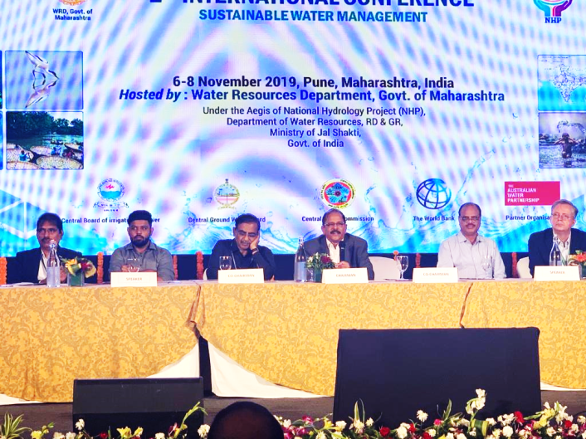

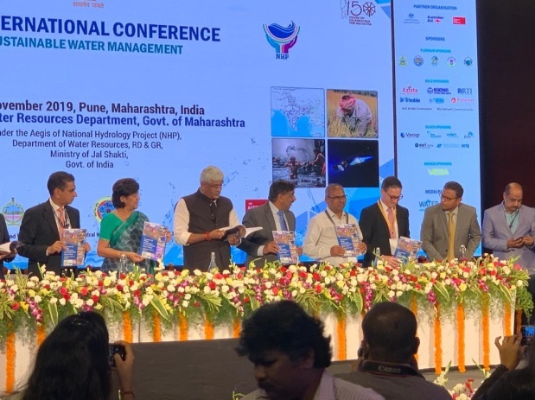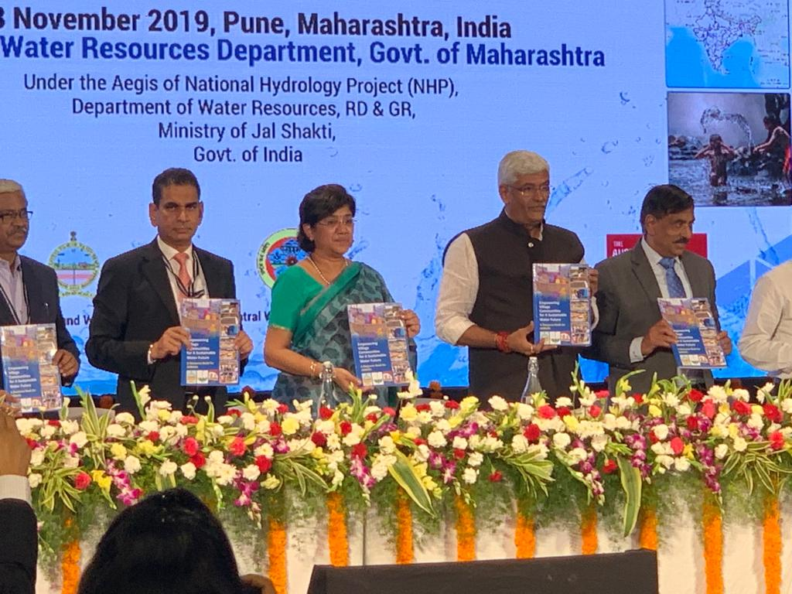

* 11th Agrovision Workshop: Hon’ble Minister Shri. Nitin Gadkari inaugurated the 11th Agrovision Workshop on 22nd Nov., 2019 at Reshim bagh Grounds, Nagpur. Dr. P.K. Jain, Regional Director, CGWB delivered an expert talk on “Water Conservation and Artificial Recharge” in the workshop.

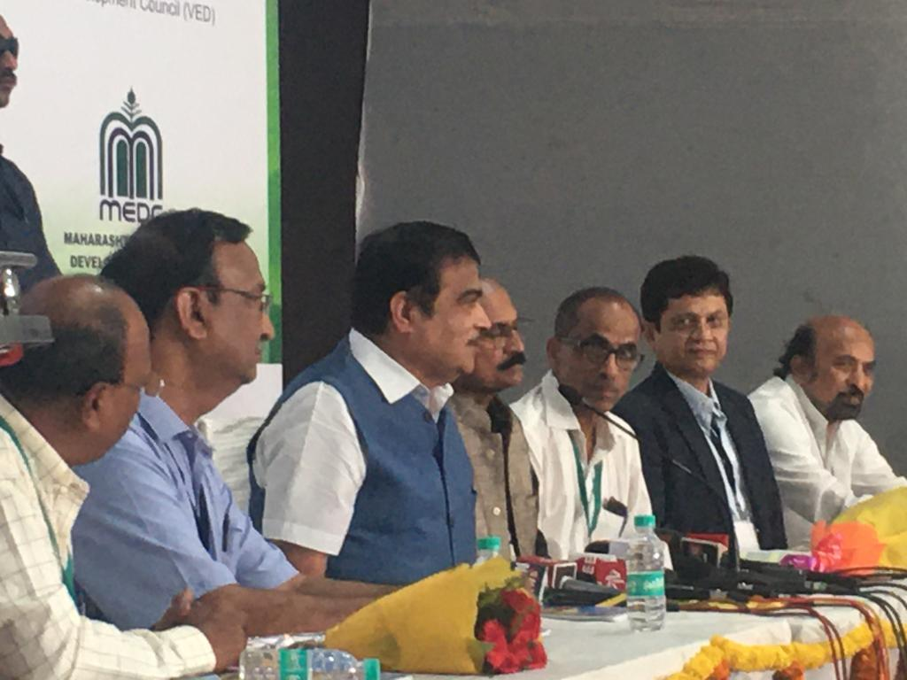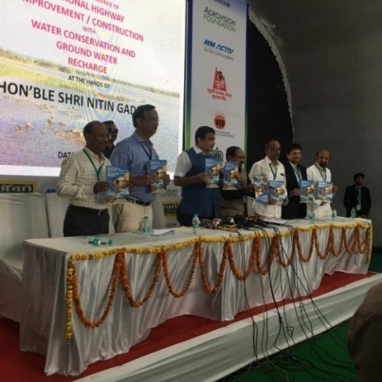

* Ms M. Bhattacharyya, ACH & Dr S. Dutta, ACH from CGWB, Kolkata participated in the International conference on “Sustainable Water Management” 6 - 8 November, 2019 at Pune and presented Papers on “Assessment of water quality and effect of TOC on it” & “Impact assessment of Urbanization of Ground water quality and its potability’-A study in Indo Bangla Border district of Tripura, India”.
* Sh. V. Elanchelian, Scientist-D (Sr.HG) and A. Sreenivas, Scientist-D (Sr.HG) from CGWB, Chennai participated in the one day inaugural workshop on Water Security & Climate Adaptation in Rural Areas (WASCA) convened by the Additional Chief Secretary, Rural Development and Panchayat Raj Department, Government of Tamil Nadu at Chennai on 29.12.2019. WASCA is a bilateral technical cooperation project between Government of India, represented by Ministry of Rural Development, Ministry of Jal Shakti and Government of Germany by GIZ (Indo - German Cooperation for International Cooperation). In Tamil Nadu, the project is to be implemented in two districts namely Ramanathapuram and Tiruvannmalai.

**(e) Meetings with State Departments / Organisations**

* Fourth TCC meeting: Shri. S.S. Hegde, Scientist-D and Shri. S.D. Waghmare, Scientist-B from SUO, Pune and Shri. Kalyan Jatav, Executive Engineer, CGWB, Division-VI, Nagpur attended the fourth TCC meeting for Inspection of 121 area specific AR structures in MR-12 & MR-13 semi-critical watersheds in taluk and district Osmanabad, on 26.11.2019 followed by field visit. The meeting was chaired by Dr. P.K. Jain, Regional Director, CGWB, Nagpur.

|  |  |  |
| --- | --- | --- |
| DSC00807.JPG | DSC00816.JPG | DSC00817.JPG |

* Sh. D. Bagchi, Sc-B from CGWB, Kolkatta attended a meeting on “Capacity Building for Adaptation Planning”, organized by Depth of Science, Technology & Biotechnology, Govt. of West Bengal on 26.11.2011
* Sh. S. M. Hossain, Sc-D attended the NAQUIM review meeting at CHQ, Faridabad on 28.11.2019
* The Regional Director, CGWB, Patna attended a meeting of sub-group for Bihar state under chairmanship of the Chief Engineer, CWC for assessment of CCA, IPC and IPU by various sources on 14.11.2019. It was decided that MWRD and WRD, Govt. of Bihar will submit reports by mid-December and then in a meeting the discussion will be held on validity of data.
* The Regional Director attended a meeting related to filing of reply of NGT O.A. in the office of Principal Secretary, Urban Development Department on submission of water conservations schemes and creation of State Ground Water Authority on 14.11.2019.
* The Regional Director and Sri D. Khanikar, Scientist-C CGWB, Guwahati attended the 4th meeting of Technical Advisory Committee (TAC) of NERIWALM on 29th November, 2019 at Tezpur.
* Sri Tapan Chakraborty, Scientist D and OIC Shillong attended meeting of the District Level Committee on Ground Water Resources held on 12th November 2019 at the Office chamber of the Deputy Commissioner, East Khasi Hills District,Shillong
* A meeting was held on 05/11/2019 at conference hall of CGWB, Chandigarh under the Chairmanship of Regional Director, Chandigarh regarding “Punjab Deep Aquifer Analysis” along with delegates from Mekorot Water Company, Israel. The officers of Water Resources Department, Punjab were also present in the meeting.

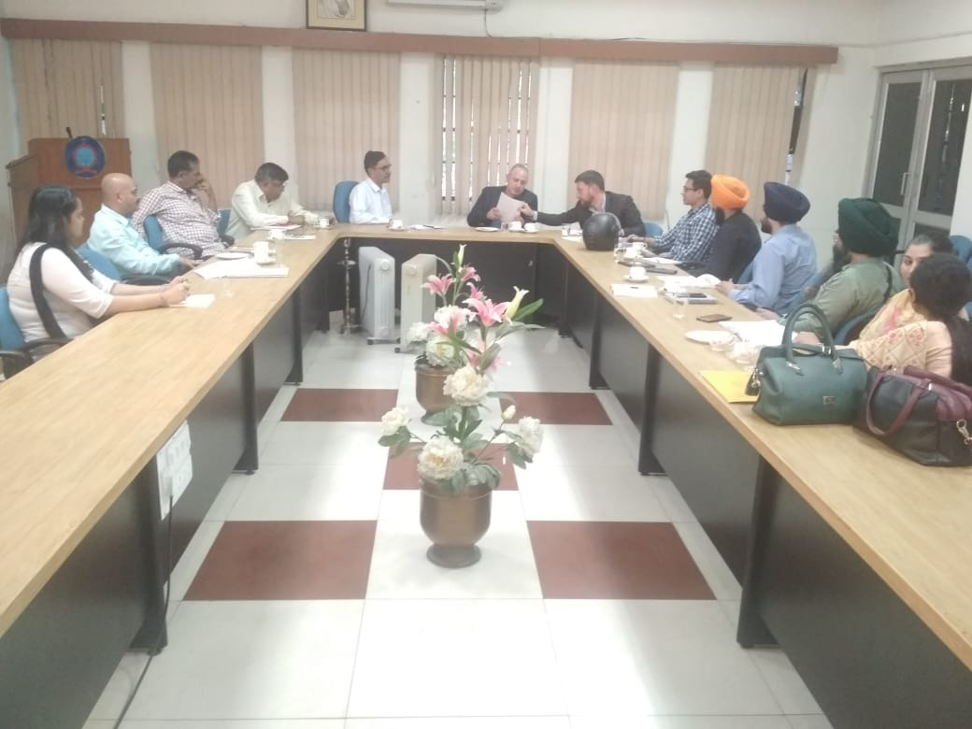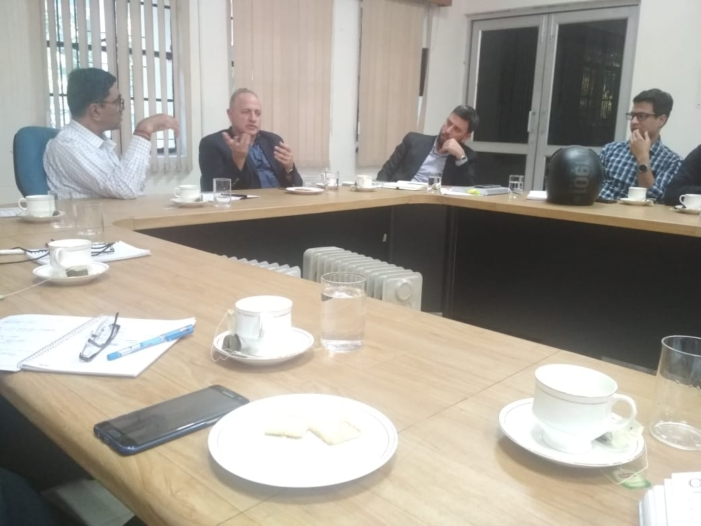

**(f) Publications**

* Ms. Pournima Barahate, Sc-B presented a paper on “Delineation of Aquifer in Washim District, Maharashtra” in National seminar on “Challenges in Ground Water and Surface water Resources in India” on 28-11-2019 at VANAMATI, Nagpur.
* Shri. P. Narendra, Sc-D (GP) presented a paper on “ Integrated Hydrogeological and Geophysical Approach for delineating GW potential zones, Narkhad Taluka, Maharashtra” in National seminar on “Challenges in Ground Water and Surface water Resources in India” on 29-11-2019 at VANAMATI, Nagpur.

**2. IMPORTANT POLICY MATTERS HELD UP ON ACCOUNT OF PROLONGED INTER-MINISTERIAL CONSULTATIONS:**

**3. COMPLIANCE OF CoS DECISIONS:**

|  |  |  |
| --- | --- | --- |
| No. of CoS decisions pending for compliance | Proposed action plan/ time lines for compliance of CoS decisions | Remarks |
|  |  |  |

**4. NO OF CASES OF ‘SANCTION FOR PROSECUTION’ PENDING FOR MORE THAN THREE MONTHS:**

**5. PARTICULARS OF CASES IN WHICH THERE HAS BEEN A DEPARTURE FROM THE TRANSACTION OF BUSINESS RULES OR ESTABLISHED POLICY OF THE GOVERNMENT**

**6. OTHER ACTIVITIES**

* **Public Interaction Programme- 16 PIPs were done in the month of November with 1766 participants-**
* In West Bengal, 6 No. of Public Interaction Programme (PIP) were organized on the theme “Aquifer Maps and Management Plans”, during November 2019. All the PIPs were held in blocks where NAQUIM studies have been completed.
  + 4 nos. of PIPs were organized in arsenic affected blocks of Nadia district, which is also an Aspirational district. 350 people (64 females) participated in the program.
  + 2 nos. of PIPs were organized in arsenic affected blocks of Hooghly district. 171 people (25 females) participated in the program.
* Six Public Interaction Programs were organized at Temla, Mandwadi, Raikhed, Mankui, Sanpkhedi and Ghattya village of Pansemal & Rajpur blocks in Barwani district of Bhopal state from 19 to 21.11.2019 with total participants of 796.
* Four Public Interaction Programs were organized at Mundla Barol, Jhadla, Berasia & Tumliakhedi villages of Narsinghgarh and Rajgarh blocks in Rajgarh district, Bhopal from 27 to 28.11.2019 with total participants of 449.

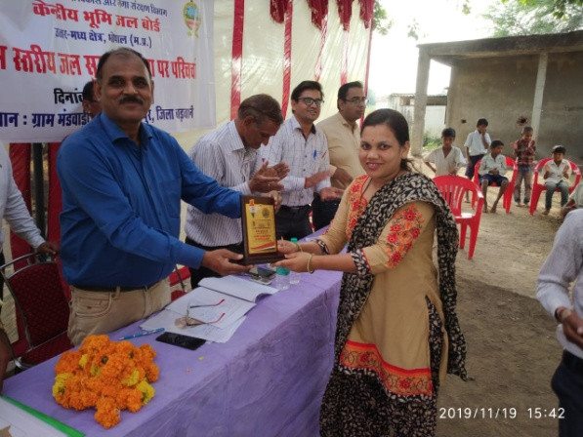 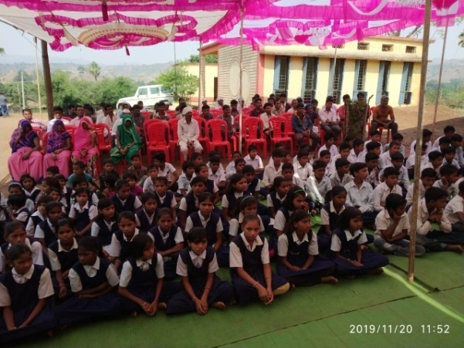

Public Interaction Program at Raikhed village, Pansemal block, Distt Barwani - 70 school children also participated along with other participants.

Public Interaction Program at Mandwadi village, Rajpur block, Distt Barwani on 19.11.2019

* **Communal Harmony Campaign week-** Communal Harmony week was observed in all the offices of CGWB from 19th to 25th Nov., 2019. Essay writing competition was organized at CGWB Bhopal for promoting Communal Harmony Campaign.

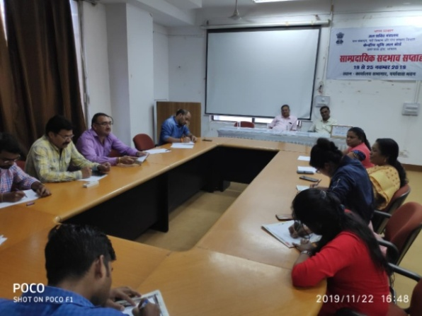

Essay writing competition during Communal Harmony Campaign week observance

* **Programs under Swachhta Abhiyan-** 
  + Under Swachhta Action Plan, the Awareness Campaign on ‘Clean water and Protection’ was conducted at Travancore Titanium Products Ltd., Thiruvananthapuram on 5.11. 2019.
  + Swachhta Abhiyan was organized on 7th November at Temri village, Chhattisgarh state where all the officers and official of CGWB, Chhattisgarh participated.
  + Cleanliness drive was conducted under Swachhtta Action Plan 2019-20 by SECR, Chennai at Turn Bulls Park, Chennai on 21.11.2019. All officers and staff of SECR, Chennai participated in the event.